The Pirate Bay

🔹 Definition
# Source: ScreenShots Source: Provided by: [Persons Table -> ID Column: 1, Name_En Column: Motasem Essam] -> Tool: [Lightshot Program] -> From [Site: https://thepiratebay.org/index.html] on [11/13/2025]
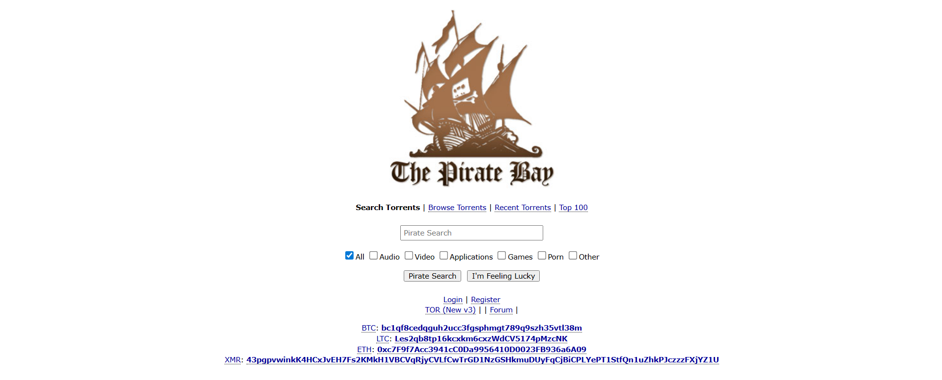
# Source: AI Source: Provided by: [Data Path: Persons Table -> ID Column: 1, Name_En Column: Motasem Essam] -> From: [ChatGPT] on [11/13/2025]
The Pirate Bay (TPB) is one of the most well-known file-sharing and torrent websites in the world. Here’s a detailed breakdown:
- It provides a search engine for torrent files and magnet links, which are used for peer-to-peer (P2P) file sharing through the BitTorrent protocol.
- Users can download or share large files such as movies, music, software, games, books, and more.
- The site itself does not host the files directly; it hosts torrent files or magnet links that allow users’ devices to connect and exchange pieces of the files with each other.

⚖️ Legality and Controversy
# Source: AI Source: Provided by: [Data Path: Persons Table -> ID Column: 1, Name_En Column: Motasem Essam] -> From: [ChatGPT] on [11/13/2025]
- Copyright issues: Many of the files shared on TPB are copyrighted and distributed without permission, making them illegal in most countries.
- Legal actions: The Pirate Bay has faced numerous legal challenges globally. Several countries have blocked access to it, and founders have been prosecuted and fined in multiple cases.
- Risk to users: Downloading copyrighted content from TPB can expose users to copyright infringement claims or malware embedded in torrents.

🔒 Security and safety risks
# Source: AI Source: Provided by: [Data Path: Persons Table -> ID Column: 1, Name_En Column: Motasem Essam] -> From: [ChatGPT] on [11/13/2025]
- Torrents from TPB may contain malware, viruses, or unwanted software, especially when downloading cracked software or unofficial media.
- Using a VPN is common among users to protect privacy, but it doesn’t make downloading illegal content legal.

⚠️ Summary
# Source: AI Source: Provided by: [Data Path: Persons Table -> ID Column: 1, Name_En Column: Motasem Essam] -> From: [ChatGPT] on [11/13/2025]
- The Pirate Bay is essentially a torrent index site that enables peer-to-peer file sharing.
- While it offers free access to a huge library of content, much of it is copyrighted and downloading it can be illegal depending on your country.
- Even legally, using TPB carries security risks.

